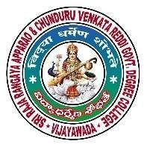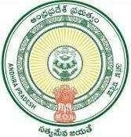
Commissionerate

of

Collegiate
Education

Government

of

Andhra

Pradesh

Water security

Community

Service

Project

Report

submitted

to

SRR

&

CVR

GOVERNMENT

DEGREE
COLLEGE (A), VIJAYAWADA

in

partial

fulfillment

of

the

requirements

for

the

award

of

the

degree

of

Bachelor

of

Science

Submitted

by

T. Vijay

Narendra

B
.
sc COMPUTER SCIENCE

Regd.

No
2436
60
47

Under

the

Mentor

Dr.

K Rajinikanth

Lecturer

in

Mathematics
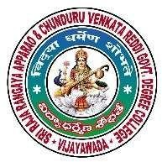
SRR

&

CVR

GOVT.

DEGREE

COLLEGE

(
A)
VIJAYAWADA

CERTIFICATE

This is to certify that the Community Service Project entitled with

Water Security

submitted

to

SRR

&

CVR

GOVERNMRNT

DEGREE COLLEGE (A), VIJAYAWADA
in partial fulfillment to the
requirements

for

the

award

of

the

degree

of

BACHELOR

OF

SCIENCE

is

done BY
by

T.VIJAY NARENDRA
,

CS
,

Reg.

No

2436
6047
,

for

the

academic

year

202
4
-

202
B.S

Place:

Date:

Signature of the Mentor

Signature

of

the

CSP

Coordinator

Signature of the Principal
(
Dr.

K.

BHAGYA

LAKSHMI)

DECLARATION

I,

Mr.
T. Vijay Narendra

hereby

declare

that

the

Community

Service
Project Report
entitled with
Water Security

has been prepared by me in partial
fulfillment to the requirements for the award of the degree of Bachelor of Science
for the academic year 202
4
-
202
5
.

This

project

work

was

carried

out

by

me

under

the

guidance

of

Sri.

K.

Rajinikanth
,

Lecturer

in

mathematics
.

I

also

declare

that

this

project

is

a

result

of

my

own

effort.

Place:

Date:

T. Vijay

N
arendra

ACKNOWLEDGEMENT

It is a pleasure to thank the many

people who extend their valuable co
-
operation
towards to made this Community Service Project possible.

I

deem

it

a

great

privilege

and

pleasure

to

express

my

deep

sense

of

gratitude

and
heartfelt thanks to
Dr. K. BHAGYA LAKSHMI
, Principal ,

SRR & CVR
Government College (A), Vijayawada for giving the opportunity to take up the
project

her Valuable suggestions and encouragement.

I
would
also
like
to
express
my
sincere
thanks
towards

Sri
.

K.
RAJINIKANTH
, Community Service Project Coordinator for providing
her guidance throughout the duration of the project.

I

would

like

to

thank

my

Community

Service

Project

Mentor

Sri.

K.

RAJINIKANTH
,

Lecturer

in

Statistics

for

his

valuable

time

spent

and

continued assistance for the successful completion of this project.

.

I

would

like

to

thank

my

other

teachers

,

family

,

friends

and

relatives

for
spending time .

Commissionerate of Collegiate Education , Government of Andhra Pradesh
SRR & CVR Govt. Degree College (A), Vijayawada – 4
Format - III Community Service Project (CSP) - Student Daily Progress Report

1 | Name of the Student | T. Vijay Narendra
2 | Regd. No. of the Student | 24366047
3 | Year | 2024-2025
4 | Program studying ( BA/B.Com/B.Sc etc., ) | 1st BSC
5 | Program Combination(Group) | computer Science
6 | Name of the Mentor | Sri. K. Rajinikanth
7 | Name of the CSP | WATER SECURITY
8 | Place of CSP execution | Purushotapatnam,gannavaram
S.No | Date | Work done | No.of hours spent
1 | May 6, 2025 | Discussed with Mentor and selected the topic | 4 Hours
2 | May 8, 2025 | Area selection and interacted with area volunteer for the necessary guidance, support to do the survey on personal transport | 4 Hours
3 | May 10, 2025 | Preparing objectives with the help of mentor. | 4 Hours
4 | May 14, 2025 | Preparation of Questionnaire with help of mentor | 4 Hours
5 | May 17, 2025 | Survey door to door in KL RAO COLONY Center of selected area | 4 Hours
6 | May 19, 2025 | Survey door to door in KL RAO COLONY Center of selected area | 5 Hours
7 | May 23, 2025 | Survey door to door in in KL RAO COLONY Center of selected area | 4 Hours
8 | May 27, 2025 | I will collect the my area information about population. | 2 Hours
9 | May 31,2025 | Discuss with mentor on project status. | 4 Hours
10 | June 2, 2025 | Data analysis & interpretation. | 2 Hours
11 | June 4, 2025 | Data analysis & interpretation. | 2 Hours
12 | June 7, 2025 | Data analysis & interpretation. | 2 Hours
13 | June 10, 2025 | Data analysis & interpretation. | 4 Hours
14 | June 13, 2025 | Data analysis & interpretation. | 4 Hours
15 | June 15, 2025 | Awareness programme on Water security | 4 Hours
16 | June 18, 2025 | Awareness programme on Water security | 4 Hours
17 | June 19, 2025 | Awareness programme on Water security | 4 Hours
18 | June 20, 2025 | Report writing | 4 Hours
19 | June 23, 2025 | Project report preparation | 4 Hours
20 | June 27, 2025 | Project report preparation | 4 Hours
21 | June 29, 2025 | Preparing presentation of csp | 4 Hours
22 | June 30, 2025 | Preparing presentation of csp | 4 Hours

Signature of the Student Signature of the Mentor
INDEX

CONTENTS

PAGE

No.

1.

INTRODUCTION

&

OBJECTIVES

2.

SOCIO
-
ECONOMIC

SURVEY

OF

HABITATION

3.

QUESTIONNAIRE

AND

DATA

INTERPRETATION

4.

PROBLEMS

IDENTIFIED

AND

SOLUTION

SUGGESTED

5.

COMMUNITY

AWARENESS

PROGRAMME

6.

PHOTOS

i.

SURVEY

ii.

COMMUNITY

AWARENESS

PROGRAMME

7.

CONCLUSIONS

8.

REFERENCES




INTRODUCTION

Water security
Water security is a growing concern worldwide, driven by factors like population growth, urbanization, climate change, and resource degradation. It involves managing both too much and too little water, as well as ensuring water quality. Water is fundamental to human well-being, economic prosperity, and environmental sustainability, making its management a critical issue.
Objectives of Water Security:
The overarching objective of water security is to ensure a sustainable and equitable supply of water for all, encompassing:
- Access:
Providing sufficient quantities of safe and affordable water for drinking, sanitation, and other essential uses.
- Protection:
Protecting against water-related hazards like floods and droughts, as well as waterborne diseases.
- Ecosystems:
Preserving the health and functionality of aquatic ecosystems and the services they provide.
- Socio-economic Development:
Ensuring water security supports livelihoods, economic growth, and overall wellbeing.
- Political Stability:
Minimizing the potential for water-related conflicts and promoting cooperation over shared water resources.


objectives of water security

The primary objectives of water security are to ensure the availability of sufficient, safe, and reliable water resources to meet human needs and ecosystem requirements, while also minimizing the risks associated with water scarcity, floods, droughts, and pollution. This includes promoting sustainable water management practices, improving water use efficiency, and ensuring equitable access to water for all.
Here's a more detailed breakdown of the objectives:
- Availability and Access:
  - Sufficient Water Resources:
Ensuring enough water is available to meet the needs of all users, including households, agriculture, industry, and ecosystems.
  - Safe and Reliable Drinking Water:
Providing access to clean, safe, and reliable drinking water sources for all communities.
  - Equitable Access:
Ensuring that water resources are distributed fairly and that all communities have access to the water they need, regardless of their social or economic status.
- Water Quality:
  - Protection of Water Resources:
Safeguarding water sources from pollution and contamination to maintain their quality for various uses.
  - Water Treatment:
Implementing effective treatment processes to remove pollutants and ensure water quality meets acceptable standards.
  - Pollution Prevention:
Reducing and preventing pollution from various sources, including industrial discharges, agricultural runoff, and urban wastewater.
- Sustainable Management:
  - Efficient Water Use:
Promoting efficient water management practices across all sectors, including agriculture, industry, and urban areas, to reduce water demand.
  - Water Conservation:
Encouraging water conservation measures to reduce overall water consumption and protect water resources.
  - Integrated Water Resources Management:
Managing water resources in a holistic and integrated manner, considering the interactions between different water sources and users.
  - Adaptive Management:
Developing flexible and adaptable water management strategies to address the challenges of climate change and other uncertainties.
- Risk Mitigation:
  - Flood Management:
Implementing effective flood management strategies to minimize flood risks and protect communities from damage.
  - Drought Management:
Developing drought preparedness plans and strategies to mitigate the impacts of droughts on water resources and livelihoods.
  - Infrastructure Resilience:
Ensuring that water infrastructure is resilient to natural disasters and other disruptions.
- Governance and Policy:
  - Water Governance:
Establishing effective water governance frameworks that promote transparency, accountability, and stakeholder participation in water management.
  - Policy Implementation:
Developing and implementing water policies that support sustainable water management and ensure water security for
Water security has emerged in the 21st century as a powerful construct to frame the water objectives and goals of human society and to support and guide local to global water policy and management. Water security can be described as the fundamental societal goal of water policy and management. This article reviews the concept of water security, explaining the differences between water security and other approaches used to conceptualize the water-related challenges facing society and ecosystems and describing some of the actions needed to achieve water security. Achieving water security requires addressing two fundamental challenges at all scales: enhancing water’s productive contributions to human and ecosystems’ wellbeing, livelihoods and development, and minimizing water’s destructive impacts on societies, economies, and ecosystems resulting, for example, from too much (flood), too little (drought) or poor quality (polluted) water.
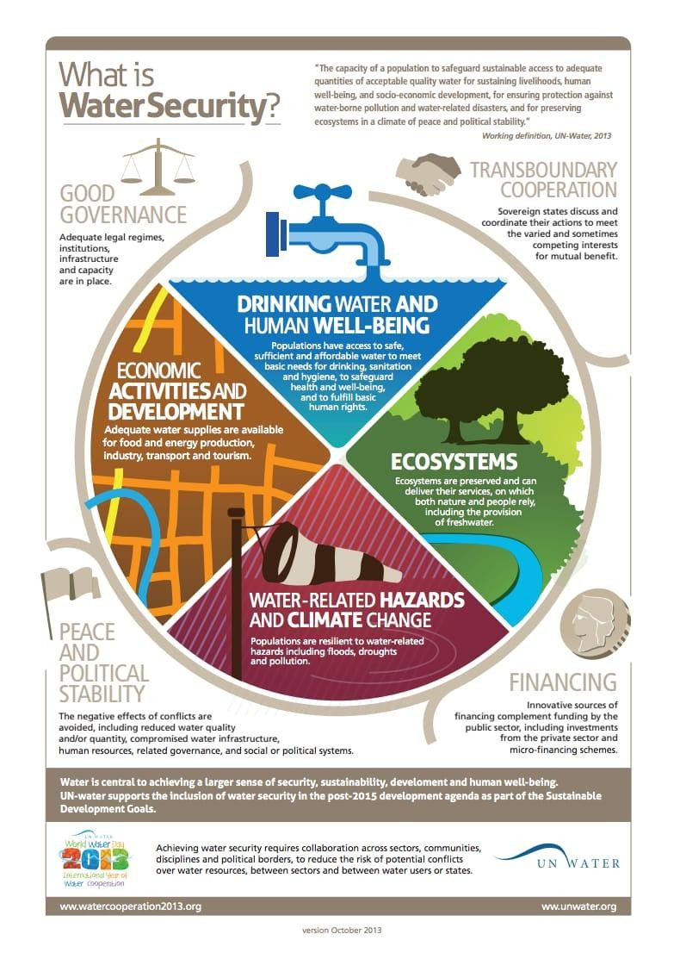

2.

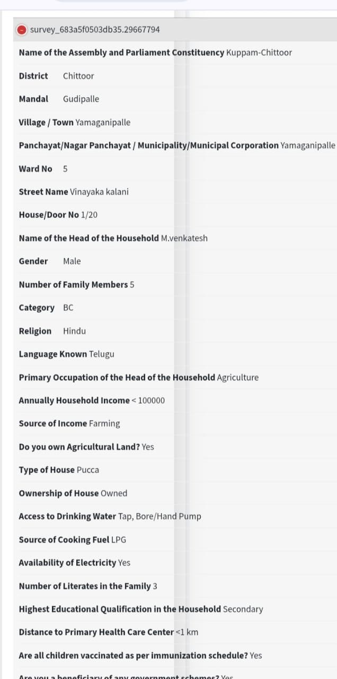
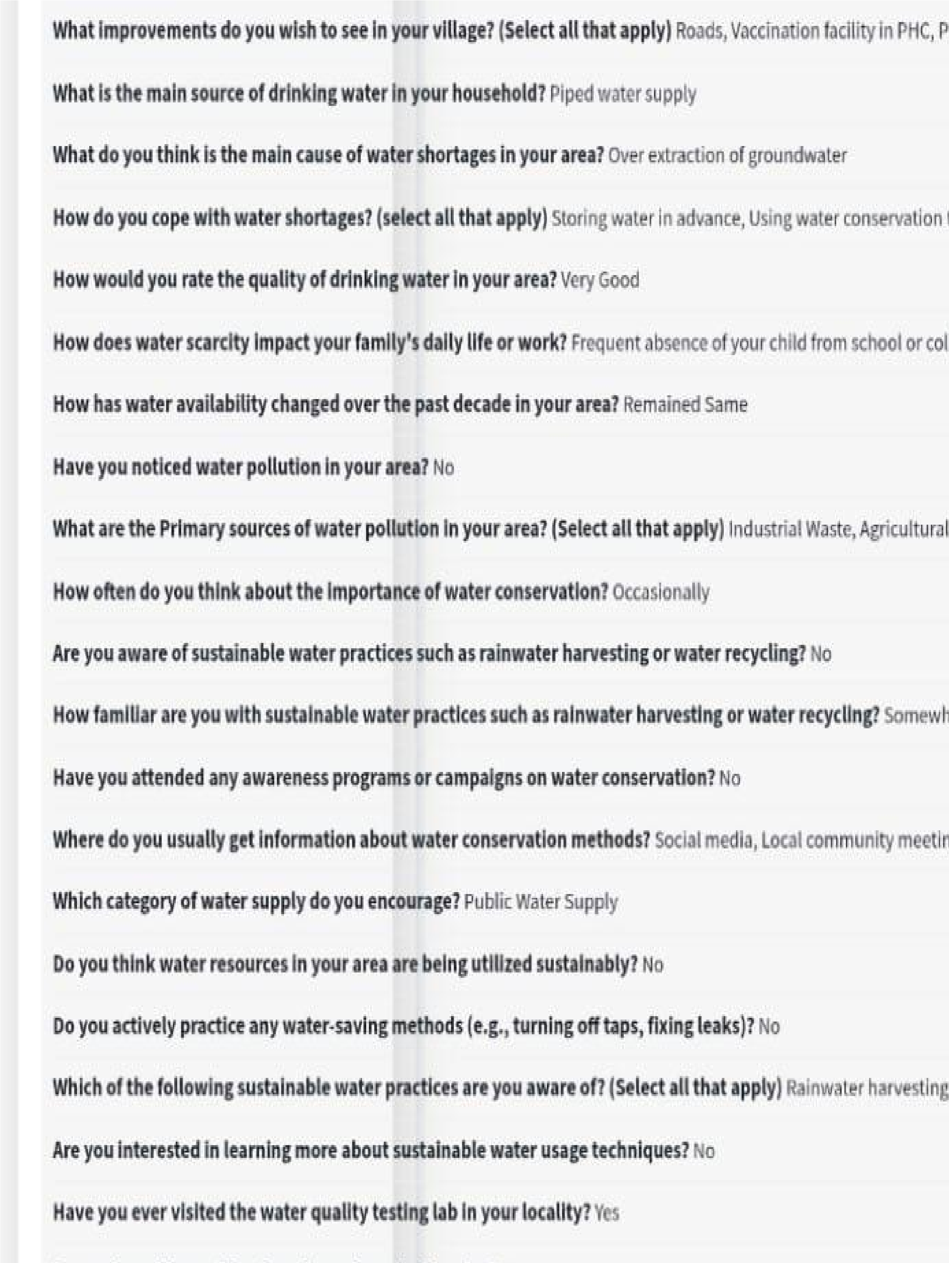

3.

- Name of the Assembly and Parliament Constituency Vijayawada CentralVijayawada ➢ District :
- Mandal :
- Village / Town:
- Panchayat/Nagar Panchayat / Municipality/Municipal Corporation:
- Ward No :
- Street Name :
- House/Door No:
- Name of the Head of the Household : ➢ Gender :
- Number of Family Members :
- Category :
- Religion :
- Language Known :
- Primary Occupation of the Head of the Household :
- Annually Household Income < 100000 ➢ Source of Income Farming ➢ Do you own Agricultural Land?
- Type of House :
- Ownership of House Rented
- Access to Drinking Water Tap, Well
- Source of Cooking Fuel LPG
- Availability of Electricity Yes
- Number of Literates in the Family 2
- Highest Educational Qualification in the Household Primary ➢ Distance to Primary Health Care Center :
- Are all children vaccinated as per immunization schedule?
- Are you a beneficiary of any government schemes? ➢ If yes, specify the schemes Water scheme ➢ Do you have a Ration Card?
- Accessibility to Internet Yes
- Mode of Transport :
- Distance to the nearest government school :
- Distance to the nearest college :
- What improvements do you wish to see in your village?
- What is the main source of drinking water in your household?
- What do you think is the main cause of water shortages in your area?
- How do you cope with water shortages?
- How would you rate the quality of drinking water in your area?
- How does water scarcity impact your family's daily life or work? ➢ How has water availability changed over the past decade in your area? Improved Significantly
- Have you noticed water pollution in your area?
- What are the Primary sources of water pollution in your area?
- How often do you think about the importance of water conservation? ➢ Are you aware of sustainable water practices such as rainwater harvesting or water recycling?
- How familiar are you with sustainable water practices such as rainwater harvesting or water recycling?
- Have you attended any awareness programs or campaigns on water conservation?
- Where do you usually get information about water conservation methods?
- Which category of water supply do you encourage?
- Do you think water resources in your area are being utilized sustainably?
- Do you actively practice any water-saving methods (e.g., turning off taps, fixing leaks)?
- Which of the following sustainable water practices are you aware of? ➢ Are you interested in learning more about sustainable water usage techniques?
- Have you ever visited the water quality testing lab in your locality?
- Do you have idea on Ph value of your household water?
- What is the quality of ground water in your area?
- Do you measure quantity of Daily Water Consumption in your family?
- What challenges do you face in adopting water-efficient practices? Cost of implementation
- Have you installed rainwater harvesting systems at your home or farm? ➢ If you not installed rainwater harvesting systems at your home or farm, what are the primary reasons?
- How effective do you think rainwater harvesting could be in addressing water shortages in Andhra Pradesh?
- Have you seen any community-level rainwater harvesting systems in your area?
- Would you be willing to contribute (financially or otherwise) to setting up rainwater harvesting systems in your community?
- Are you aware of the Jal Jeevan Mission that provides safe drinking water to every household?
- How satisfied are you with the implementation of the Jal Jeevan Mission in your area?
- What is the current status of the Jal Jeevan Mission in your area?
- Has the Jal Jeevan Mission improved access to drinking water in your household?
- Do you believe the Jal Jeevan Mission has effectively addressed water scarcity issues in rural area? ➢ How would you rate the quality of drinking water in your area provided under Jal Jeevan Mission?
- Have you faced Health issues due to water contamination after Jal Jeevan Mission implementation? ➢ Which of the following measures are necessary for the further improvement of the Jal Jeevan Mission?
- Are you willing to participate in government-led water conservation initiatives?
- How often do you discuss water-related issues with your community?
- Do you think community involvement is crucial for improving water security?
- How effective are local government authorities in addressing water-related concerns?
- Though Municipal Water provided in your area is of good quality for household do you prefer purchasing water from bottles/tin/bubbles?
- Why do people in your area buy bottled water instead of municipal tap water
for household needs?

*DATA ANALYSIS*

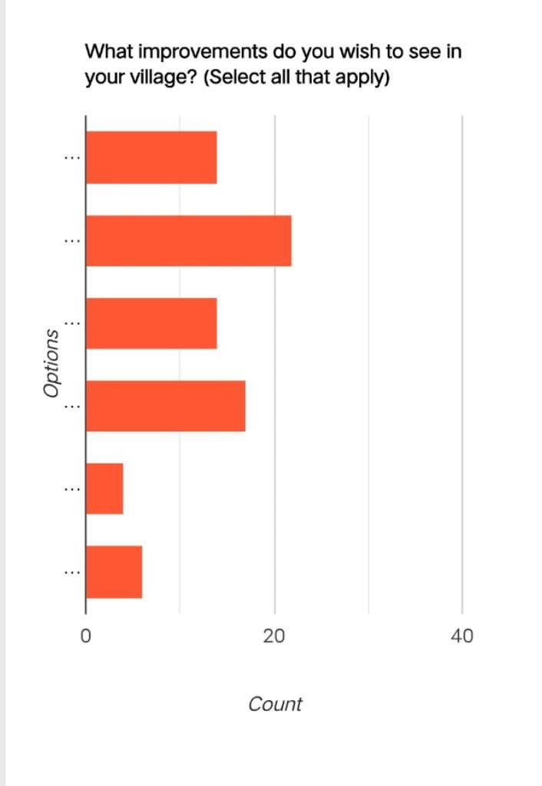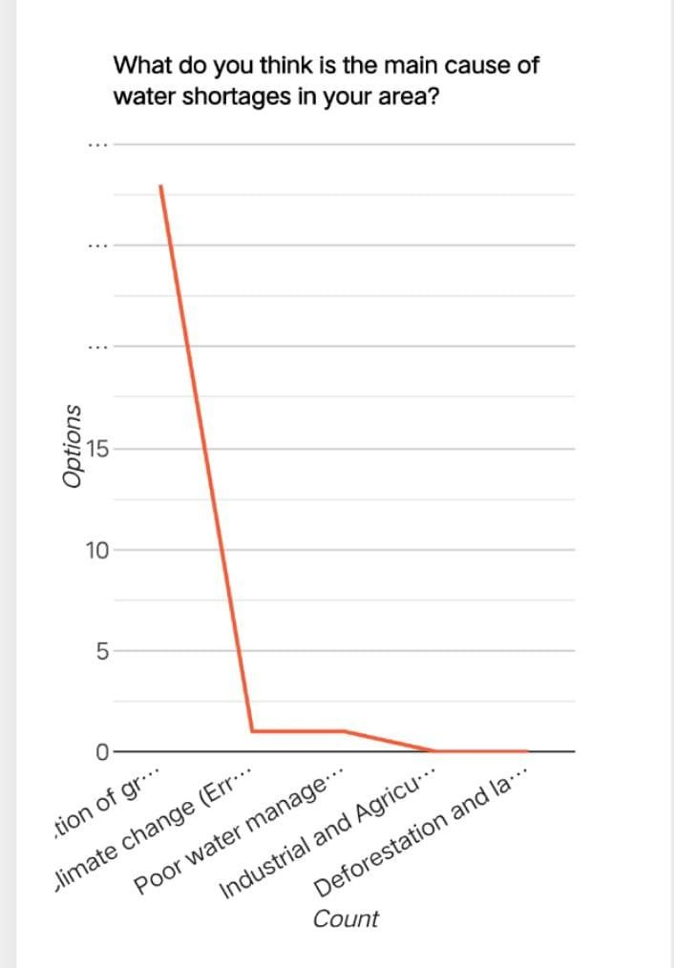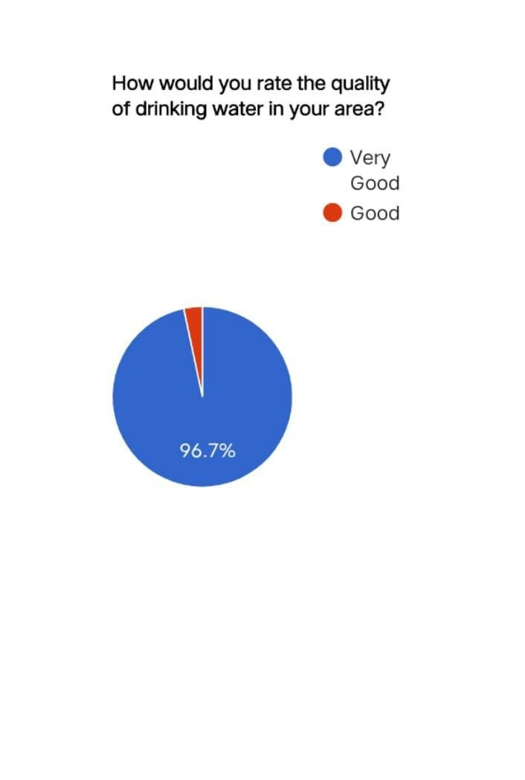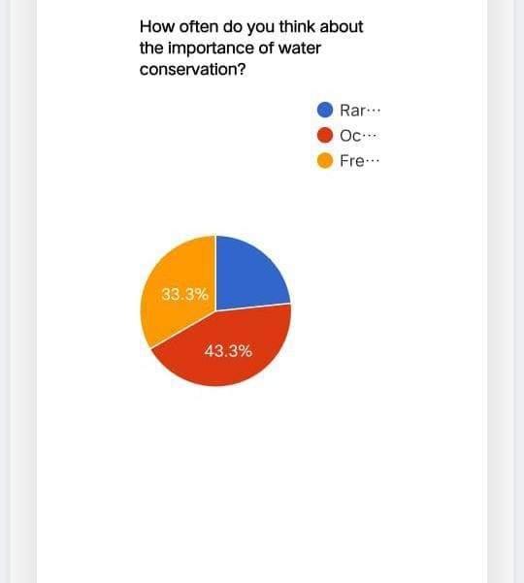

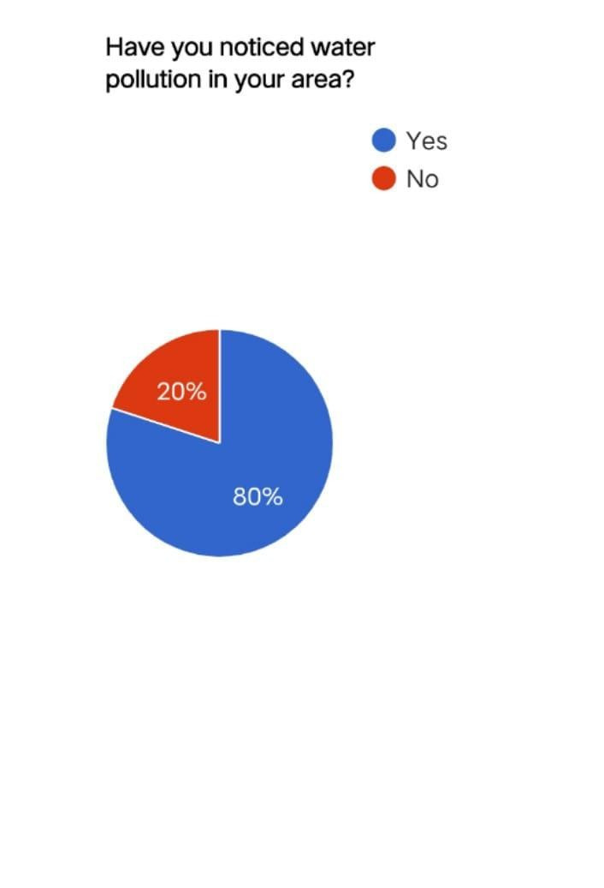
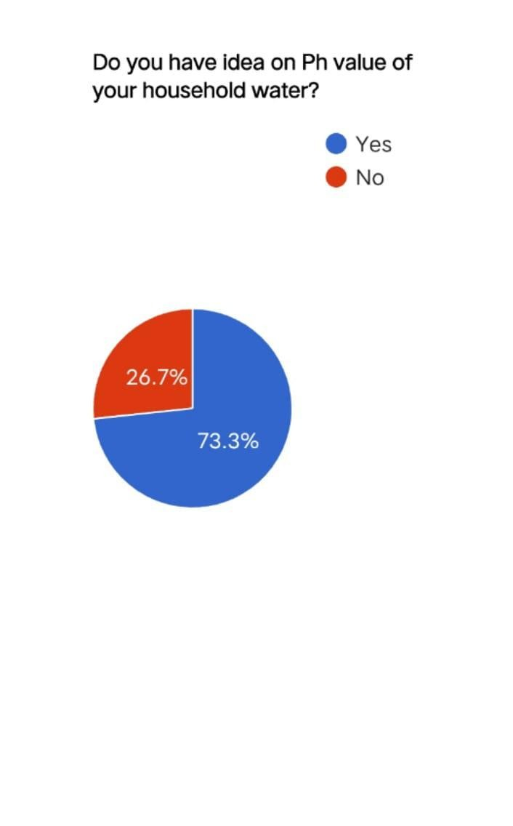
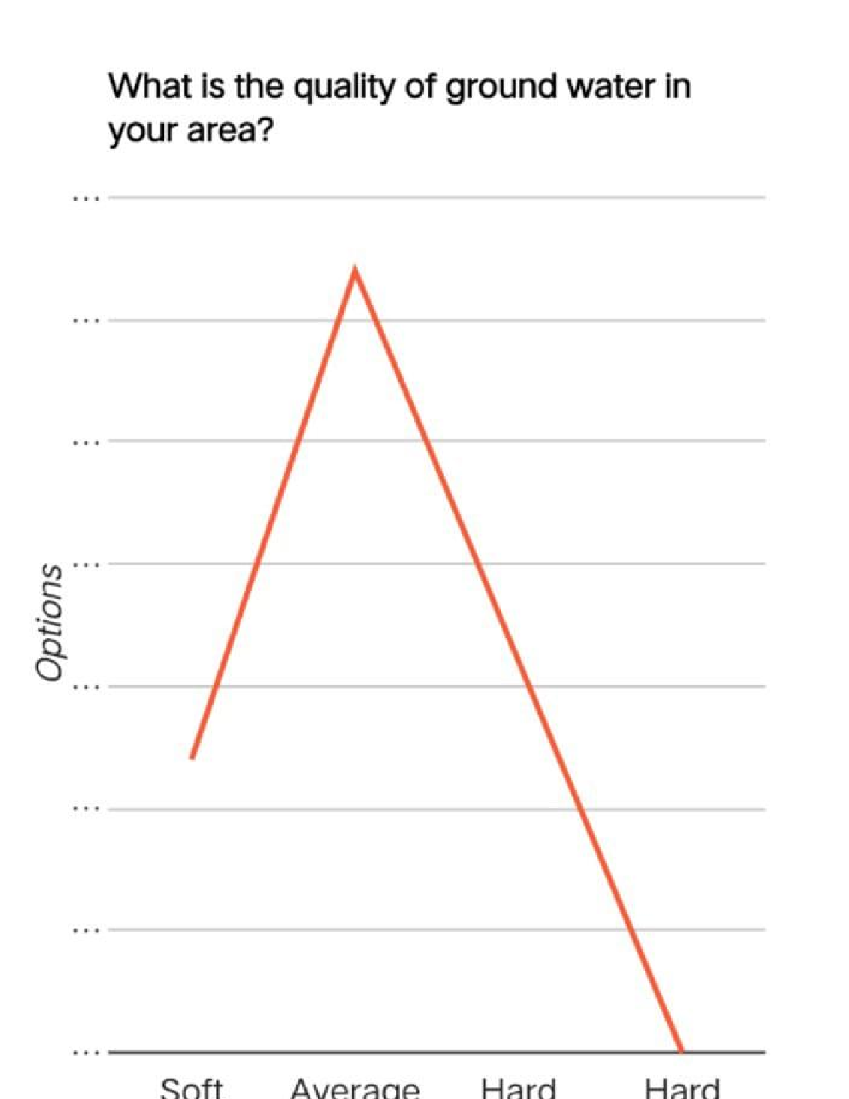
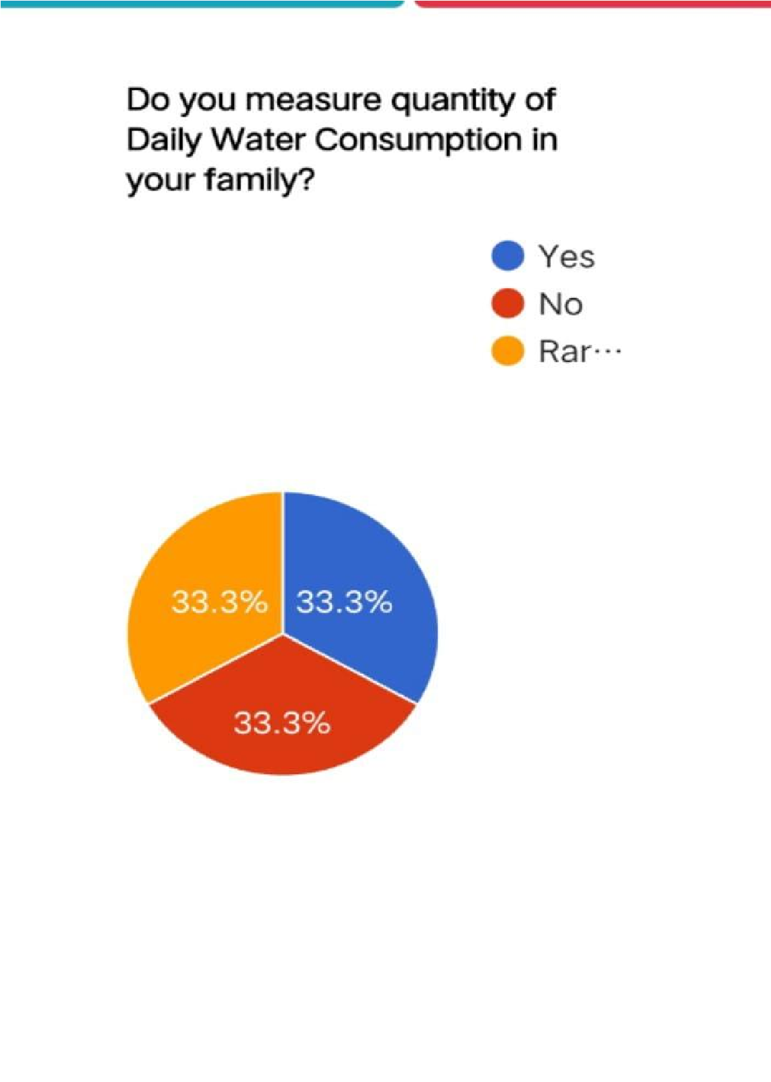
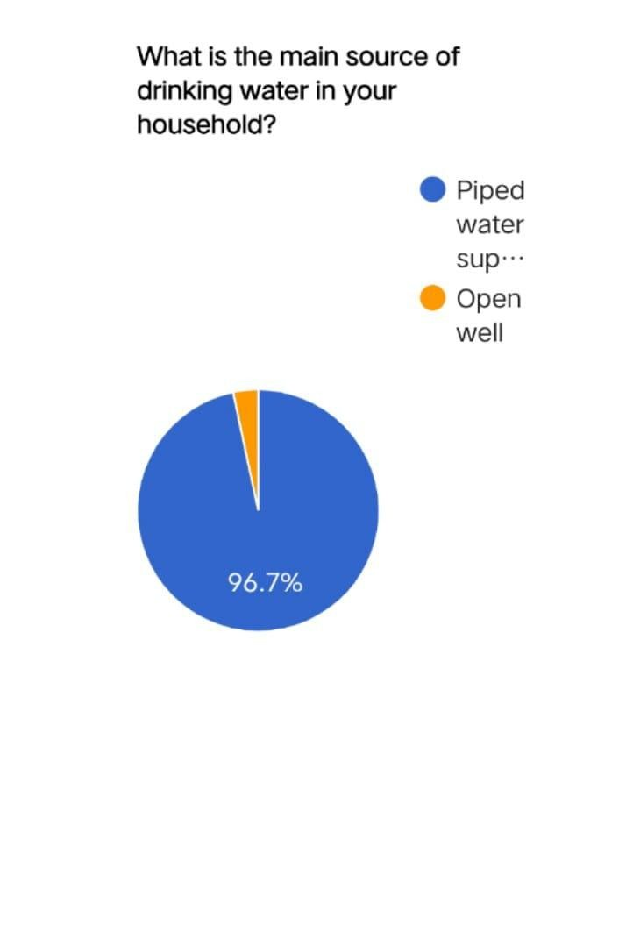

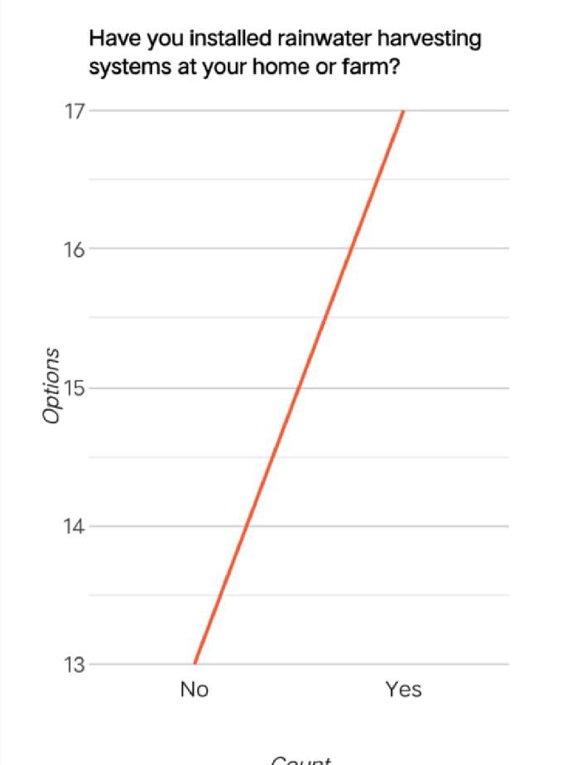
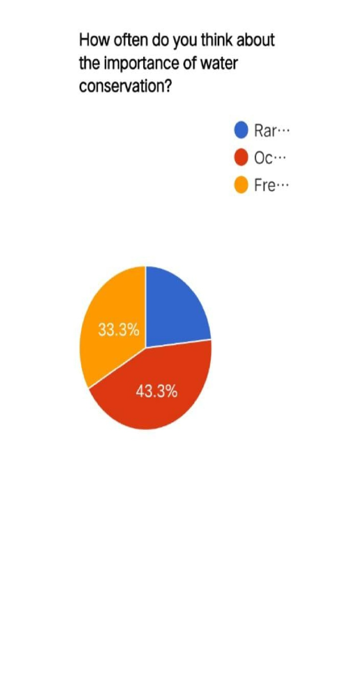
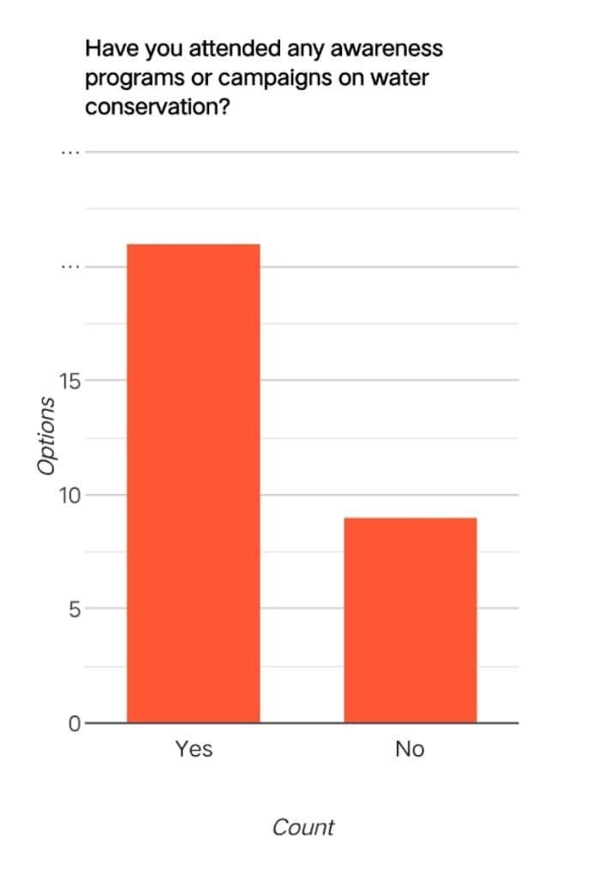


4.

Problem 1: Inadequate Access to Clean and Reliable Water
- Cause: Poor infrastructure, unequal distribution, over-reliance on groundwater.
- Impact: Health issues, reduced quality of life, social and economic stress.
Suggested Solution:
- Upgrade and maintain public water supply systems.
- Expand piped water access to underserved areas.
- Promote decentralized purification systems (community water tanks, filters).

Problem 2: Overuse and Wastage of Water Resources
- Cause: Inefficient usage in households, agriculture, and industry.
- Impact: Faster depletion of water sources, especially groundwater. Suggested Solution:
- Encourage water-saving technologies (low-flow taps, drip irrigation).
- Conduct public awareness campaigns on water conservation.
- Implement tiered pricing to reduce wasteful consumption.

Problem 3: Declining Groundwater Levels
- Cause: Excessive extraction, lack of recharge, low rainfall.
- Impact: Dry wells, land subsidence, long-term water insecurity.
Suggested Solution:
- Implement groundwater regulation laws.
- Promote rainwater harvesting and recharge wells.
- Map and monitor aquifers regularly.

Problem 4: Lack of Rainwater Harvesting
- Cause: Lack of awareness, investment, or regulation.
- Impact: Loss of usable rainwater, increased urban flooding. Suggested Solution:
- Make rainwater harvesting mandatory for new buildings.
- Provide subsidies or incentives for installation.
- Promote rooftop and community-level harvesting systems.

Problem 5: Pollution of Water Sources
- Cause: Industrial discharge, sewage, and agricultural runoff.
- Impact: Unsafe drinking water, waterborne diseases, ecosystem damage.
Suggested Solution:
- Strengthen enforcement of pollution control laws.
- Set up decentralized sewage treatment plants (STPs).
- Promote organic farming and eco-friendly industry practices.

Problem 6: Weak Community Participation
- Cause: Lack of education and engagement in water governance.
- Impact: Poor enforcement of policies, low adoption of conservation practices.
Suggested Solution:
- Form local water user groups or councils.
- Educate communities through workshops and campaigns.
- Include citizens in planning and decision-making.

A community awareness program on water security in Vijayawada would focus on educating residents about the importance of water conservation, sustainable water management practices, and the impact of water scarcity. The program would likely involve workshops, community events, and educational materials to promote responsible water usage and encourage participation in local water conservation efforts.
Here's a more detailed look at what such a program might entail:
Key Objectives:
- Increase awareness:
Educate the community about the importance of water conservation and the challenges of water scarcity, especially in the context of kuppam's location and climate.
- Promote sustainable practices:
Encourage the adoption of water-saving techniques in households, agriculture, and other sectors.
- Foster community participation:
Encourage residents to actively participate in local water conservation initiatives.
- Highlight the role of local water bodies:
Raise awareness about the importance of rivers like the Dam and their role in the city's water supply.
- Address specific challenges:
Tailor the program to address issues like groundwater depletion, water pollution, and the impact of flooding.
Program Activities:
- Workshops and Training:
Conduct workshops on topics like rainwater harvesting, greywater reuse, and efficient irrigation techniques.
- Community Events:
Organize events like tree planting drives, clean-up campaigns, and water conservation fairs to engage residents.
- Educational Materials:
Distribute pamphlets, posters, and other materials to provide information on water conservation practices.
- School Programs:
Collaborate with local schools to educate students about water conservation and its importance.
- Partnerships:
Collaborate with local NGOs, government agencies, and community leaders to maximize the program's reach and impact.
Specific Focus Areas:
- Water Sources:
Highlight the importance of both surface water (rivers, canals) and groundwater resources.
- Water Usage:
Promote efficient water use in households, agriculture, and industries.
- Water Quality:
Raise awareness about the importance of preventing water pollution and protecting water bodies.
- Climate Change:
Discuss the impact of climate change on water resources and the need for adaptation.
Expected Outcomes:
- Increased water conservation:
A more water-conscious community will likely lead to reduced water consumption and improved water management practices.
- Improved water quality:
Increased awareness about water pollution and the importance of protecting water bodies can lead to cleaner water sources.
- Greater community engagement:
A successful program can foster a sense of collective responsibility and encourage residents to participate in local water conservation efforts.
• Sustainable water management:
By promoting sustainable practices, the program can contribute to longterm water security for kuppam .
By implementing such a comprehensive community awareness program, kuppam can work towards ensuring a sustainable water.



As students, we see that water security in Purushotapatnam is an important issue that affects our daily lives, health, and future. Although the city gets water from the Pollavaram Dam, problems like water pollution, wastage, and uneven supply still exist. Many people don’t have access to clean water all the time, especially during summer.
We believe it’s important for everyone — including students — to be aware of how we use water and take small steps to save it. Simple actions like turning off taps, using water wisely at home and school, and supporting rainwater harvesting can make a big difference. If we all work together and support smart water management, Purushotapatnam can have a safe and secure water future for the coming generations.



SURVEY
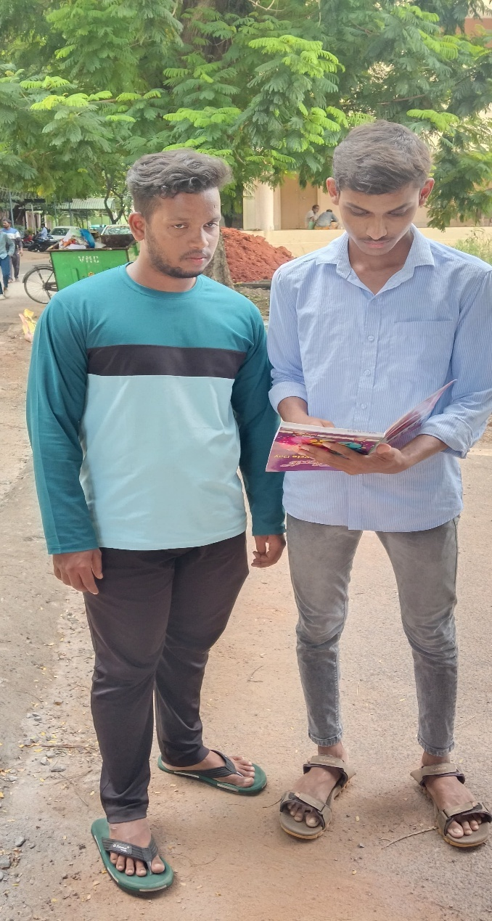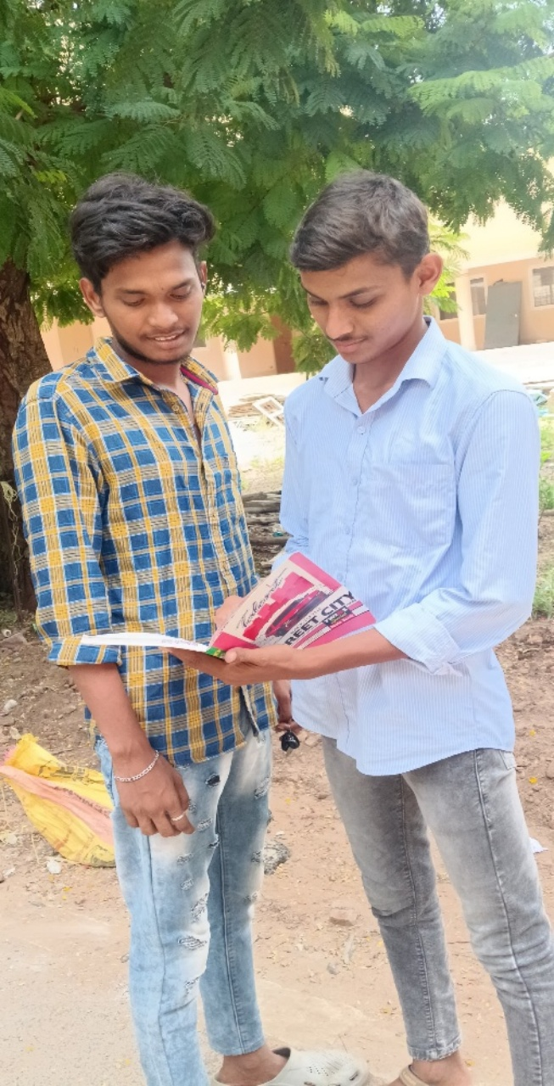

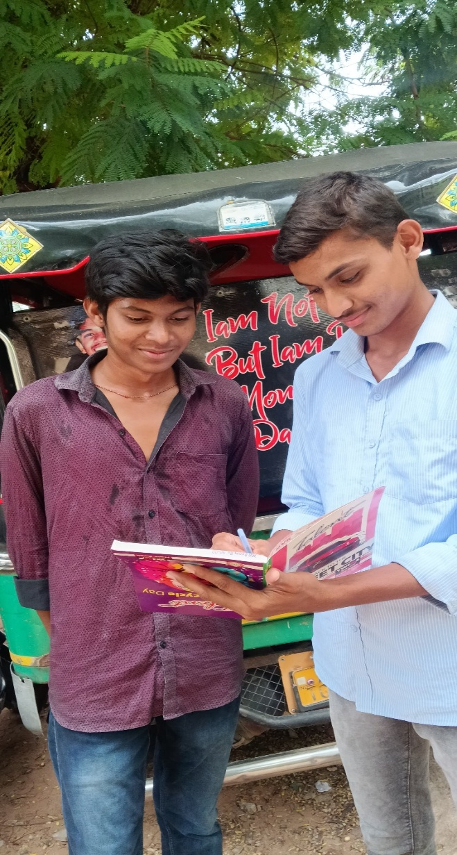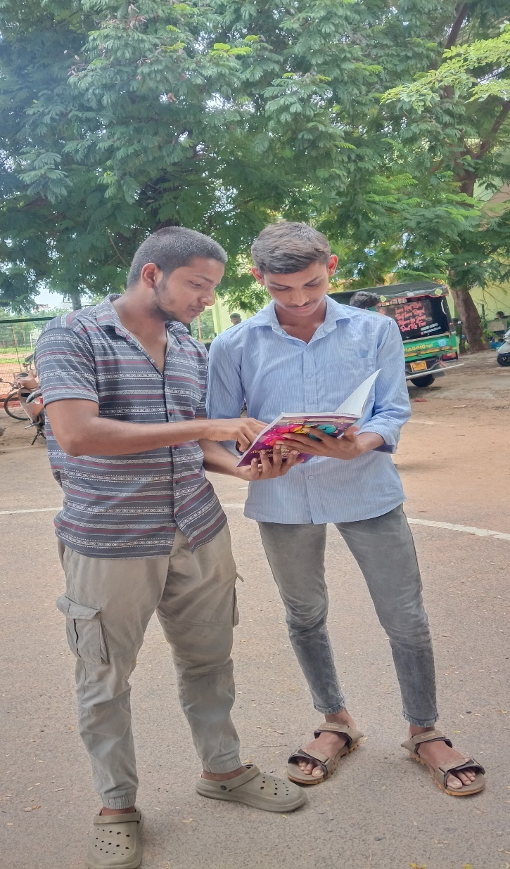

REFERENCES

- UN-Water

- UNESCO

- Global Water Partnership (GWP)

- Water.org

- India-WRIS

- APWRIMS (Andhra Pradesh Water Resources Information and Management system.
te

